**Game Development:**

**Lab 14**

Task 1:

In a unity scene, using a c# script, make cube rotate with “R” key, Move Left with “Left arrow” key move right with “Right Arrow key, move up with “u” key and down with “d” key.

Task 2:

In a unity scene, make a cube rotate by applying animation to it. Make sure no script is attached with the cube

Steps:

1. Bring a cube and plane into your scene and apply desirable Material on it.
2. Select the cube, goto Windows🡪Animations🡪Animation
3. Click create button, and save animation as “cubeRotation” in animation folder.
4. Add property🡪click Transform🡪add + sign and then add rotation value =50 on left side Rotation options as shown below:

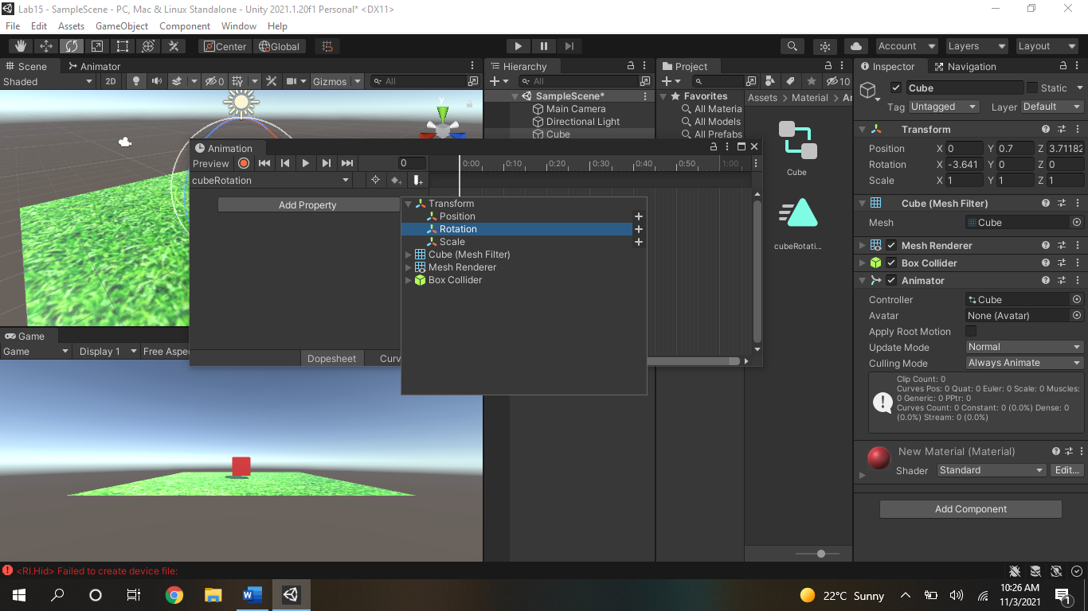

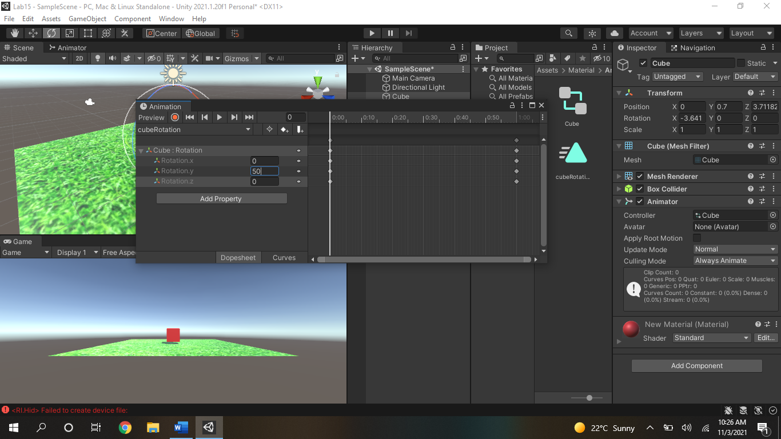

1. Play the scene and see if cube is rotating.

Task 3:

In a unity scene bring a cartoon character and make it fall down by making an animation by yourself.